Identification of Metallic Rods via the Coefficient of Thermal Expansion

By David Jefts, Alden Arien Amulyoto, Tsion Eshetu

PS253 Physics Laboratory for Engineers

Section 08, Dona Kuruppuaratchi & Dylan Labbe

Department of Physical Sciences

Embry-Riddle Aeronautical University, Daytona Beach, Florida

8th of October 2018

**Abstract**

The goal of this experiment was to successfully identify the makeup of three different metal rods after calculating their thermal expansion coefficients. To do this, we placed each of the three rods inside of a hollow rod that was then placed in a very accurate machinist’s dial indicator, which measured the change in length, and then pumped full of boiling hot steam. The hot steam caused each of the rods to expand, and we used the temperature difference and the change in length of each of the rods to calculate the thermal expansion coefficients for each rod. Our experiment was considered to be a success if we identified the rods and our thermal expansion coefficients were within a 5.0% difference of the literature values [2]. The three rods we tested were identified by their physical appearance as the Shiny Silver Rod (144.5±.05g), the Shiny Gold Rod (159.9±.05g), and the Rusty Silver Rod (145.85±.05g) [1]. After our calculations we failed to conclusively determine the material makeup of the three rods but predicted that the first rod was made of aluminum, the second of brass, and the third was composed of iron.

**Background**

Thermal expansion is the tendency of matter to change in shape, area, and volume in response to a change in temperature [3]. This experiment was based around identifying materials based on the Coefficient of Thermal Expansion, a property of materials that relates the change in temperature of a material to its change in length. This coefficient varies based on the temperature range and can even be positive on over some ranges and negative on others. Water is one such material, its coefficient of thermal expansion normally has a positive value but reaches zero when the temperature reaches 3.983°C and continues to drop below that [3]. The only deviation from the lab manual was not waiting until the length dial had stopped moving and reached a “steady state”. We waited until the temperature of the rod had

balanced out but not until the length had stopped changing.

**Theory & Methods**

This experiment was composed of three separate trials, one for each of three different metallic rods. Each trial involved boiling water and using the hot steam created to heat up a rod and cause it to expand. To accomplish this, we placed a small boiler tank filled about a third of the way on a hot plate and heated it up. The boiler had a nozzle located near the top that we attached plastic tubing to, this is where the steam was collected from. This tubing led to a pipe with three nozzles, within which was the rod that was being tested. The pipe had two sections, one for steam and one for the rod. Steam flowed from the boiler and through the pipe via the plastic tubing and one of the nozzles on. it. Our temperature sensor was also connected to the pipe via the second nozzle.

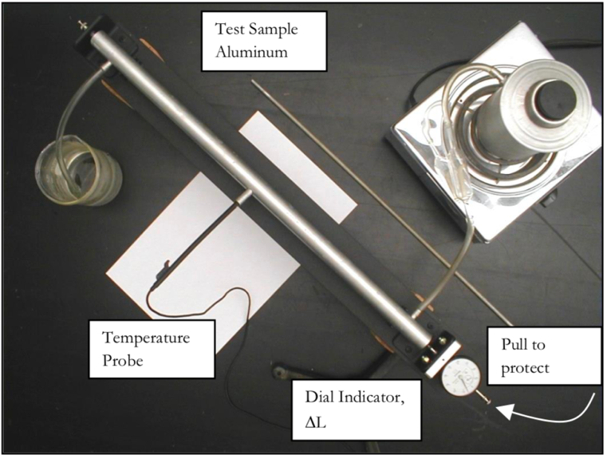

*Figure 1: Visual representation of the Thermal Expansion Apparatus used in this experiment. The metal steam boiler on the upper right supplies steam to the pipe running from. The lower right to the upper left where the steam then vents and condenses in a cool bath of water. [2]*

The third nozzle let steam flow from it via additional tubing into an overflow beaker containing cold water to condense the steam flowing through the system. Figure 1 depicts this system in its entirety. The temperature probe is used to measure the initial and final temperatures of the rods inserted into the pipe during each trial and these values were used to calculate ΔT, the change in temperature of the rod. The temperature of the room was used for the initial temperature since all of the rods were stored in the lab room. The final temperature was measured to be just below the boiling temperature for water (100°C) for all three trials. Once the temperature of the piping leveled out and the dial on the machinist’s dial indicator began to move very slowly we measured our ΔL, the change in length of the pipe.

**Results**

The coefficient of thermal expansion is different for every material and is related to the change in length and temperature of the material in question as shown in Equation 1.

$\frac{∆L}{L_{O}}=α\left(T_{f}-T_{i}\right)$ (1)

Alpha (α) is the Linear Coefficient of Thermal Expansion, Ti was the initial temperature of the rod (and the room), Tf was the final temperature of the rod (just below the boiling point for water), LO was the initial length of the rod, and ΔL was the change in length of the rod. Our experimental values for all of the measured values (ΔL, LO, Tf, Ti) can be found in the Raw Data section. The coefficient for each rod was calculated by solving Equation 1 for alpha (2).

$α=\frac{∆L}{L_{O}\left(T_{f}-T_{i}\right)}$ (2)

For Rod 1, the Shiny Silver Rod, the coefficient was calculated to be $32.71±.114×{10}^{-6}\frac{1}{C°}$ [1]. Rod 2, the Shiny Gold Rod, had a coefficient of $14.08±.109×{10}^{-6}\frac{1}{C°}$ [1]. The final rod, the Rusty Silver Rod, had a coefficient of thermal expansion of $9.68±.116×{10}^{-6}\frac{1}{C°}$ [1]. The uncertainty (the number after the “±” symbol) for each of these values had to be propagated, by finding partial differential of Equation 2 in terms of each of the 4 measured variables; ΔL, LO, Tf, Ti. These partials are equations 3, 4, 5, and 6, respectively.

$\frac{∂α}{∂∆L}=\frac{1}{L_{O}\left(∆T\right)}$ (3)

$\frac{∂α}{{∂L}_{O}}=\frac{-∆L}{{\left(L_{O}\right)}^{2}∆T}$ (4)

$\frac{∂α}{{∂T}_{f}}=\frac{-∆L}{L_{O}{\left(∆T\right)}^{2}}$ (5)

$\frac{∂α}{{∂T}_{i}}=\frac{∆L}{L_{O}{\left(∆T\right)}^{2}}$ (6)

$δ_{f}=\sqrt{{\left(\frac{∂f}{∂x}×δ_{x}\right)}^{2}+{\left(\frac{∂f}{∂y}{×δ}_{y}\right)}^{2}+…}$ (7)

Equation 7.1:

$$δ_{α}=\sqrt{{\left(\frac{∂α}{∂∆L}×δ_{L_{f}}\right)}^{2}+{\left(\frac{∂α}{{∂L}_{O}}{×δ}_{L_{O}}\right)}^{2}+{\left(\frac{∂α}{{∂T}_{f}}{×δ}_{T_{f}}\right)}^{2}+{\left(\frac{∂α}{{∂T}_{i}}{×δ}_{T_{i}}\right)}^{2}}$$

The general formula for propagated uncertainty is Equation 7. Equation 7.1 is the specific equation for this experiment and plugging in Equations 3 through 6 to this gave Equation 8. Equation 8 can be found in the Calculations appendix. Since Equation 6 was identical to Equation 5 times negative one, Equation 8 can be simplified to Equation 9, the final formula we used to propagate the uncertainty of the Thermal Expansion Coefficient values.

Equation 9:

$$δ_{α}=\sqrt{{\left(\frac{1}{L_{O}\left(∆T\right)}×δ_{∆L}\right)}^{2}+{\left(\frac{-∆L}{{\left(L_{O}\right)}^{2}∆T}{×δ}_{L_{O}}\right)}^{2}+2×{\left(\frac{∆L}{L_{O}{\left(∆T\right)}^{2}}{×δ}_{T_{i}}\right)}^{2}}$$

Each measured value has a percent uncertainty based on the ratio of the absolute uncertainty and the actual measured value, Equation 10.

$\frac{δ_{x}}{x}×100\%$ (10)

LO had 0.083% uncertainty, ΔL had an uncertainty of 0.766%, Ti was 0.043%, Tf was 0.010%, and the percent uncertainty for ΔT was 0.027% [1].

Whether or not our experiment was a success is determined by the percent difference between the actual coefficients of the metal rods and the value we measured and calculated. The formula for this is Equation 11.

$$\frac{\left|\left(experimental value\right)- \left(actual value\right)\right|}{\left(actual value\right)}×100$$

The actual thermal expansion coefficient for aluminum is $24×{10}^{-6}\frac{1}{C°}$ [4] and the percent difference from our experiment was 36.29% [1]. This was way outside the 5% range determined acceptable for our experiment and was 76σ (uncertainties) away from the experimental value.

The actual thermal expansion coefficient for brass is $19×{10}^{-6}\frac{1}{C°}$ [4] and the percent difference from our experiment was 25.89% [1]. This was way outside the 5% range determined acceptable for our experiment and was 45σ (uncertainties) away from the experimental value.

The actual thermal expansion coefficient for iron is $11×{10}^{-6}\frac{1}{C°}$ [4] and the percent difference from our experiment was 12.00% [1]. This was way outside the 5% range determined acceptable for our experiment and was 11σ (uncertainties) away from the experimental value.

Based on the percent differences for each of the three trials we concluded that we failed to decisively determine the material makeup of any of the three rods we experimented on. This was likely due to the Systematic Measurement Source of Uncertainty caused by recording the value for ΔL before the dial on the measurement apparatus had fully stopped moving. This means that the value for ΔL that we recorded was actually much lower than the actual value, alpha is directly proportional to ΔL (Equation 2) therefore we could expect to have succeeded if we had waited a little longer before gathering our data. Additionally, there were multiple sources of Random Measurement Uncertainties due to multiple measured values with physical measurement tools though we mostly eliminated this by using very precise measurement tools, such as the machinist’s dial indicator. Finally, the thermal expansion coefficient changes based on the temperature of the material, and we assumed that the coefficient would be constant over the entire temperature range that we experimented across. This would cause a source of Random Intrinsic Uncertainty.

**References**

[1] Jefts, David. “Raw Data.” ERAU, Daytona Beach, FL, 3 Oct. 2018

[2] Schumacher, Donald. “Thermal Expansion” ERAU, Daytona Beach, FL, 30 Sept. 2016. Reading.

[3] Tipler, Paul Allen, and Gene Mosca. Physics for Scientists and Engineers. 6th ed., Macmillan, 2007.

[4] Engineering ToolBox. “Coefficients of Linear Thermal Expansion.” Young's Modulus of Elasticity for Metals and Alloys, 2003, www.engineeringtoolbox.com/linear-expansion-coefficients-d_95.html.

**Calculations**

Equation for the linear expansion of a solid

$\frac{∆L}{L_{O}}=α\left(T_{f}-T_{i}\right)$ (1)

Solve equation 1 for alpha

$α=\frac{∆L}{L_{O}\left(T_{f}-T_{i}\right)}$ (2)

Take the partial of equation 1 in terms of ∆L

$\frac{∂α}{∂∆L}=\frac{1}{L_{O}\left(∆T\right)}$ (3)

Take the partial of equation 1 in terms of LO

(4)

Take the partial of equation 1 in terms of Tf

(5)

Take the partial of equation 1 in terms of Ti

(6)

General formula to propagate the uncertainty of a calculation

$δ_{f}=\sqrt{{\left(\frac{∂f}{∂x}×δ_{x}\right)}^{2}+{\left(\frac{∂f}{∂y}{×δ}_{y}\right)}^{2}+…}$ (7)

Specific formula to propagate the uncertainty of the coefficient of linear expansion

$δ_{α}=\sqrt{{\left(\frac{∂α}{∂∆L}×δ_{L_{f}}\right)}^{2}+{\left(\frac{∂α}{{∂L}_{O}}{×δ}_{L_{O}}\right)}^{2}+{\left(\frac{∂α}{{∂T}_{f}}{×δ}_{T_{f}}\right)}^{2}+{\left(\frac{∂α}{{∂T}_{i}}{×δ}_{T_{i}}\right)}^{2}}$ (7.1)

Plug in equations 3-6 into 7

$δ_{α}=\sqrt{{\left(\frac{1}{L_{O}\left(∆T\right)}×δ_{∆L}\right)}^{2}+{\left(\frac{-∆L}{{\left(L_{O}\right)}^{2}∆T}{×δ}_{L_{O}}\right)}^{2}+{\left(\frac{-∆L}{L_{O}{\left(∆T\right)}^{2}}{×δ}_{T_{f}}\right)}^{2}+{\left(\frac{∆L}{L_{O}{\left(∆T\right)}^{2}}{×δ}_{T_{i}}\right)}^{2}}$ (8)

Simplify equation 8

$δ_{α}=\sqrt{{\left(\frac{1}{L_{O}\left(∆T\right)}×δ_{∆L}\right)}^{2}+{\left(\frac{-∆L}{{\left(L_{O}\right)}^{2}∆T}{×δ}_{L_{O}}\right)}^{2}+2×{\left(\frac{∆L}{L_{O}{\left(∆T\right)}^{2}}{×δ}_{T_{i}}\right)}^{2}}$ (9)

**Raw Data**

